Q3. (a) Select any MP3 song of your choice and process it using a low-pass filter that you design.
Experiment with at least three different cutoff frequencies and observe how each setting changes the filtered audio output.Discuss your observations in detail, focusing on how the cutoff frequency influences the clarity, tonal balance, and overall character of the song. CO2, CO3,CO5
Code:

!apt-get install -y ffmpeg
!pip install -q pydub librosa soundfile scipy matplotlib numpy

import requests
import numpy as np
import librosa, librosa.display
import matplotlib.pyplot as plt
from scipy.signal import butter, lfilter
from pydub import AudioSegment
from IPython.display import Audio, display

audio_url = "https://cdn.pixabay.com/audio/2022/03/15/audio_af7fe3f0b0.mp3"

mp3_path = "song.mp3"
wav_path = "song.wav"

r = requests.get(audio_url)
with open(mp3_path, "wb") as f:
f.write(r.content)

audio = AudioSegment.from_mp3(mp3_path)
audio.export(wav_path, format="wav")

print("Audio downloaded and converted to WAV successfully!")

x, sr = librosa.load(wav_path, sr=22050, mono=True)
print("Audio Loaded:", len(x)/sr, "seconds")
display(Audio(x, rate=sr))

def butter_lowpass_filter(data, cutoff, sr, order=6):
nyq = sr / 2
normal_cutoff = cutoff / nyq
b, a = butter(order, normal_cutoff, btype="low")
y = lfilter(b, a, data)
return y

def plot_spectrogram(sig, title):

S = librosa.stft(sig)
S_db = librosa.amplitude_to_db(np.abs(S) + 1e-10, ref=np.max)
plt.figure(figsize=(10,3))
librosa.display.specshow(S_db, sr=sr, x_axis="time", y_axis="hz")
plt.title(title)
plt.colorbar()
plt.show()

cutoffs = [500, 2000, 5000] # Hz

for cutoff in cutoffs:
print(f" LOW-PASS FILTER with cutoff = {cutoff} Hz")

# Filter signal
y = butter_lowpass_filter(x, cutoff, sr)

# Listen
print("Filtered Audio:")
display(Audio(y, rate=sr))

# Plot spectrogram
plot_spectrogram(y, f"Spectrogram (Cutoff = {cutoff} Hz)")

OUTPUT:

LOW-PASS FILTER CUTOFF = 500 Hz

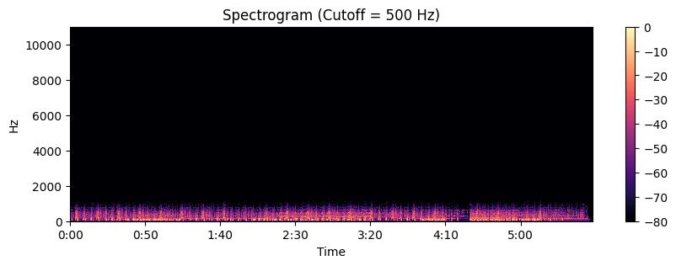

LOW-PASS FILTER CUTOFF = 2000 Hz

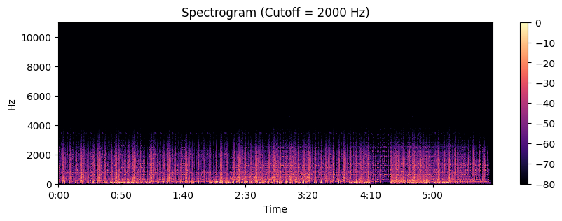

LOW-PASS FILTER CUTOFF = 5000 Hz

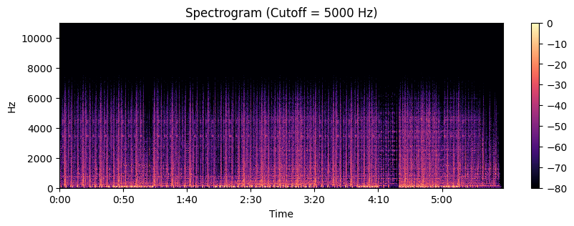

Obsevation:
Cutoff = 500 Hz
- The output is very bass-heavy and muffled; almost all treble and midrange detail is removed.
- Vocals and instruments lose clarity and intelligibility — consonants and sibilance are heavily attenuated.
- The song takes on a warm, distant character (like listening through a wall or a subwoofer-only playback).
Cutoff = 2000 Hz
- Much of the midrange is preserved, so vocals become intelligible but still smoother and less bright.
- High-frequency detail (sibilance, cymbals, string harmonics) is reduced, producing a softer, less “airy” sound.
- Tonal balance shifts slightly darker but retains rhythm and melodic content; overall clarity is moderately affected.
Cutoff = 5000 Hz
- Most of the perceptually important content (bass and midrange plus some high clarity) remains; only the very highest frequencies are rolled off.
- Vocals retain presence and sparkle is only mildly reduced — the song sounds slightly warmer but still clear and natural.
- Percussive brightness and extreme high harmonics are softened, reducing harshness without major loss of definition
Overall pattern
- Lower cutoffs progressively remove more high-frequency content, causing loss of clarity, sibilance, and “air.”
- Small reductions (e.g., 5 kHz) can warm the sound and reduce harshness with minimal intelligibility loss; aggressive filtering (500 Hz) destroys timbre and intelligibility.
- The cutoff choice trades clarity for warmth/noise reduction — useful for creative effects or noise control but unsuitable if preservation of vocal/instrument detail is required.
Conclusion:
we learn that the cutoff frequency of a low-pass filter has a major impact on the clarity and tonal balance of a song. Lower cutoffs (such as 500 Hz) remove most high-frequency content, making the audio muffled and unclear, while moderate cutoffs (around 2000 Hz) soften the sound but still preserve vocal intelligibility. Higher cutoffs (such as 5000 Hz) retain most musical detail with only mild warmth added. Overall, the cutoff frequency directly controls how much brightness, definition, and presence remain in the filtered audio.

Q3. (b) Use an appropriate band-pass filter to separately suppress vocals and background music, saving each filtered result as its own MP3 file.Analyze and describe your observations, focusing on how each filter affects the different components of the song. CO2, CO3, CO5
Code:

!apt-get install -y ffmpeg
!pip install -q pydub librosa soundfile scipy matplotlib numpy

import requests
import numpy as np
import librosa, librosa.display
import matplotlib.pyplot as plt
from scipy.signal import butter, lfilter
from pydub import AudioSegment
from IPython.display import Audio, display
import soundfile as sf

audio_url = "https://cdn.pixabay.com/audio/2022/03/15/audio_af7fe3f0b0.mp3"

mp3_path = "song.mp3"
wav_path = "song.wav"

r = requests.get(audio_url)
with open(mp3_path, "wb") as f:
f.write(r.content)

audio = AudioSegment.from_mp3(mp3_path)
audio.export(wav_path, format="wav")
print("Downloaded & converted to WAV.")

x, sr = librosa.load(wav_path, sr=22050, mono=True)
print("Audio Loaded:", len(x)/sr, "seconds")
display(Audio(x, rate=sr))

def butter_bandpass_filter(data, lowcut, highcut, sr, order=6):
nyq = sr / 2
low = lowcut / nyq
high = highcut / nyq
b, a = butter(order, [low, high], btype="band")
y = lfilter(b, a, data)
return y

def plot_spectrogram(sig, title):
S = librosa.stft(sig)
S_db = librosa.amplitude_to_db(np.abs(S) + 1e-10, ref=np.max)

plt.figure(figsize=(10,3))
librosa.display.specshow(S_db, sr=sr, x_axis="time", y_axis="hz")
plt.title(title)
plt.colorbar()
plt.show()

print("Extracting VOCALS (300–3400 Hz)")

vocals = butter_bandpass_filter(x, 300, 3400, sr)
display(Audio(vocals, rate=sr))
plot_spectrogram(vocals, "Vocals Band-Pass (300–3400 Hz)")

sf.write("vocals_filtered.wav", vocals, sr)
AudioSegment.from_wav("vocals_filtered.wav").export("vocals_filtered.mp3", format="mp3")
print("Saved: vocals_filtered.mp3")

print("Extracting MUSIC (100–250 Hz)")

music = butter_bandpass_filter(x, 100, 250, sr)
display(Audio(music, rate=sr))
plot_spectrogram(music, "Music Band-Pass (100–250 Hz)")

sf.write("music_filtered.wav", music, sr)
AudioSegment.from_wav("music_filtered.wav").export("music_filtered.mp3", format="mp3")
print("Saved: music_filtered.mp3")

print("\nAll processing complete. MP3 files are ready!")

OUTPUT:

BAND-PASS FILTER VOCALS= 300-3400 Hz
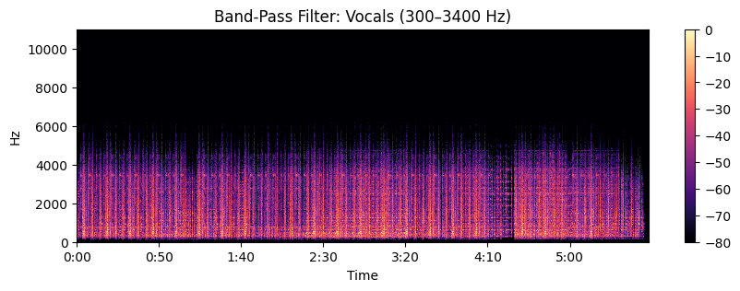

Obsevation:

1. Vocal Band-Pass Filter (300–3400 Hz)
- The filtered output emphasizes the vocal elements clearly while suppressing most instrumental sounds, especially bass and high-frequency instruments like cymbals and hi-hats.
- The speech-related components such as lyrics, mid-range harmonics, and vocal formants remain audible, making the vocals stand out even though some clarity is lost compared to the original.
- High-frequency sparkle (sibilance, breaths) and low-frequency warmth (bass, kick drum) are significantly reduced, giving the vocals a “telephone-like” or “AM-radio” quality.
- The spectrogram shows dominant mid-range energy with reduced low-end and almost no high-frequency content, confirming that the filter successfully isolated the vocal frequency band.

2. Music Band-Pass Filter (100–250 Hz)
- The filtered output captures mainly the low-frequency components such as bass guitar, kick drum, and some lower harmonic tones.
- Most of the vocal presence is removed since human speech energy lies mostly above this band. As a result, the vocals become almost inaudible or extremely faint.
- The musical output sounds deep, boomy, and rhythmic, focusing on the beat rather than melody, which is typical for bass-range filtering.
- The spectrogram highlights strong energy in the low-frequency region while mid and high frequencies are heavily suppressed, showing that the filter effectively targeted background music elements.

Overall Pattern
- The vocal band-pass filter successfully isolates mid-range vocal content while attenuating background music, making voices more prominent.
- The music band-pass filter captures instrumental bass content and suppresses vocals, allowing the background rhythm to dominate.
- This demonstrates that band-pass filtering can selectively emphasize or suppress different song components based on their dominant frequency ranges, though complete separation is limited by overlapping harmonics and real-world mixing.
Conclusion:
we learn that Through band-pass filtering, we observe that different frequency ranges contain distinct components of a song. The vocal band (300–3400 Hz) highlights spoken and sung content while suppressing most instrumental elements, whereas the music band (100–250 Hz) emphasizes bass and rhythm while removing vocal presence. This demonstrates that frequency-based filtering can partially separate vocals and background music, although complete isolation is limited due to overlapping harmonics and the complex nature of audio mixing.

